Vehicle Control Unit (VCU)
Report submitted to GITAM (Deemed to be University) as a partial fulfillment of the requirements for the award of the Degree of

Bachelor of Technology in Electrical and Electronics Engineering

DEPARTMENT OF ELECTRICAL, ELECTRONICS AND COMMUNICATION ENGINEERING
GITAM SCHOOL OF TECHNOLOGY
GITAM (DEEMED TO BE UNIVERSITY)
BENGALURU -561203
NOV 2025

Shravani C L BU22EECE0200009
Ch Pavan Kumar BU22EECE0200014
Patil Janardhan Reddy BU22EECE0200022

DECLARATION

I/We declare that the project work contained in this report is original and it has been done by me under the guidance of my project guide.

Name: Shravani C L
Ch Pavan Kumar
Patil Janardhan reddy

Date:

Signature of the Students:

Department of Electrical, Electronics and Communication Engineering GITAM School of Technology, Bengaluru-561203



CERTIFICATE

This is to certify that Shravani CL, Ch Pavan Kumar, Patil Janardhan Reddy bearing (Regd no.:BU22EECE0200009, BU22EECE0200014, BU22EECE0200022) has satisfactorily completed Mini Project Entitled in partial fulfillment of the requirements as prescribed by University for VIIth semester, Bachelor of Technology in “Electrical and Electronics Engineering” and submitted this report during the academic year 2025-2026.

[Signature of the Guide] [Signature of HOD]
Table of contents

Chapter 1: Introduction 1
  - Overview of the problem statement 1
  - Objectives and goals 1
Chapter 2: Literature Review 2
Chapter 3: Strategic Analysis and Problem Definition 3
  - SWOT Analysis 3
  - Project Plan - GANTT Chart 3
  - Refinement of problem statement 4
Chapter 4: Methodology 5
  - Description of the approach 5
  - Tools and techniques utilized 5
  - Design considerations 5
Chapter 5: Implementation 6
  - Description of how the project was executed 6
  - Challenges faced and solutions implemented 6
Chapter 6: Results 7
  - outcome 7
  - Interpretation of results 7
Chapter 7: Conclusion 8
Chapter 8: Future Work 9
References 10

Chapter 1: Introduction

  - Overview of the problem statement
- The rapid evolution of the electric mobility system has created the need for an intelligent Vehicle Control Unit (VCU) capable of supervising key automotive subsystems. In this project, the primary focus is on designing and implementing a prototype VCU responsible for motor control and battery management.
- The motor control subsystem ensures precise actuation of the electric drive using techniques such as Pulse Width Modulation (PWM) for speed regulation and torque optimization. In parallel, the battery management subsystem is designed to perform real time monitoring of critical parameters such as Voltage, Current, and State of Charge (SoC).
- To enable reliable and synchronized operation, the modules communicate via the Controller Area Network (CAN) protocol, which has become the standard in automotive applications due to its robustness, fault tolerance, and deterministic message delivery.

  - Objectives and goals
- To design and prototype of VCU for educational and experimental validation.
- To implement PWM-driven motor control strategies ensuring accurate and stable drive actuation.
- To implement battery parameter acquisition and management, including voltage and current sensing.
- To enable real-time interconnection of the motor and battery nodes using CAN communication.
- To validate the concept through breadboard-based prototyping.
Chapter 2 : Literature Review
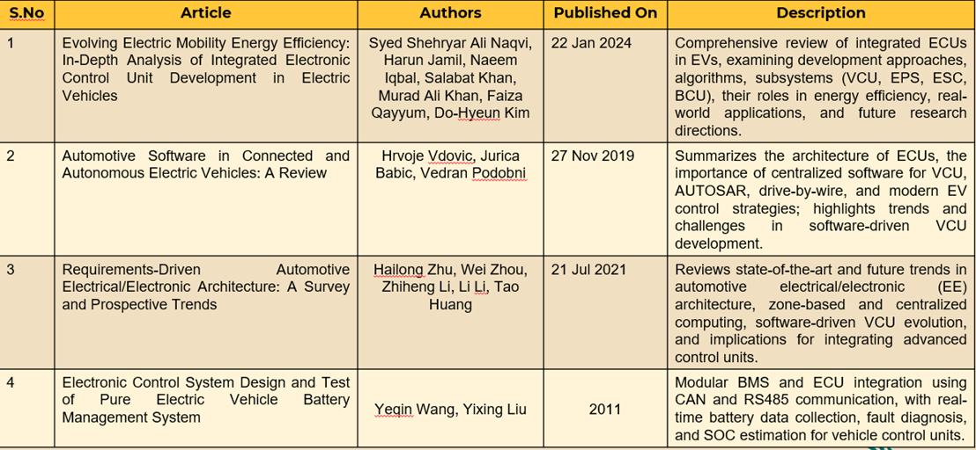
- In modern automotive systems, the Vehicle Control Unit acts as the centralized intelligence that coordinates diverse subsystems such as the traction motor, Battery Management System (BMS), regenerative braking modules, and auxiliary controllers.
- Motor Control: Research emphasizes the application of closed-loop PWM modulation, feedback from Hall sensors or encoders, and current regulation to achieve torque stability and energy-efficient operation. These methods ensure smooth drive response, reduced energy loss, and increased system reliability.
- Battery Management: A robust BMS must provide accurate SOC estimation, protect against over-voltage/under-voltage conditions, and implement cell balancing algorithms for long-term performance. Thermal monitoring and protection circuits are also critical for safety.
- CAN Communication: The CAN protocol is highlighted in multiple studies for its ability to support real-time distributed communication with high error detection capability and arbitration features that guarantee deterministic priority-driven messaging.
- This literature indicates that combining low-cost embedded controllers with CAN networking forms an ideal foundation for educational prototypes that simulate industry-grade vehicle control units
Chapter 3 : Strategic Analysis and Problem Definition
  - SWOT Analysis
Strength:
- Modular node-based architecture enabling independent development of motor and battery modules.
- Cost-effective prototyping using off-the-shelf microcontrollers.
- Flexibility to scale the system with additional subsystems such as regenerative braking.
Weaknesses:
- Breadboard limitations for handling high current applications.
- Restricted computational capacity of basic controllers compared to industrial-grade processors.
Opportunities:
- Expansion toward advanced EV-grade Battery Management Systems with thermal management.
- Future transition to real-time operating systems (RTOS) and model-based control algorithms.
Threats:
- Hardware synchronization issues under high loads.
- Potential errors in sensor calibration and data acquisition.

  - Project Plan - GANTT Chart
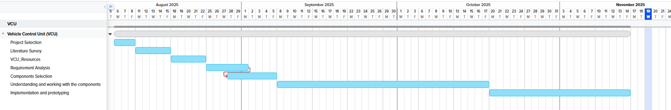

  - Problem statement
- To design and validate a Vehicle Control Unit prototype that integrates motor control and battery management subsystems, ensuring reliable operation through CAN based interoperability, while maintaining modularity, and cost efficiency.

Chapter 4 : Methodology
  - Description of the approach:
- The adopted methodology follows a node-based modular approach. One controller node is dedicated to motor control, implementing PWM techniques for speed regulation and interfacing with the motor driver circuitry. Another node functions as the battery management unit, acquiring battery parameters through voltage dividers, current sensors, and ADC channels.
- Both nodes exchange messages over a CAN bus, ensuring synchronized operation and real-time data sharing. Error-checking mechanisms inherent to CAN safeguard the communication against noise and collision.
  - Tools and techniques utilized:
- STM32 F767ZI Microcontroller board.
- Embedded C/C++ programming.
- STM32 CubeIDE for firmware development.
- 40A Electronic Speed Controller.
- Small Battery pack (2 cells).
- 10㏀ potentiometer.
- Breadboard and supporting hardware components.
  - Design considerations:
- Isolation and safety in battery sensing circuits.
- Stable PWM generation for motor drive control.
- Scalability for additional subsystems.
- Ensuring deterministic communication cycles via CAN arbitration.

Chapter 5 : Implementation
  - Description of how the project was executed:
- Development Environment Setup & Basic MCU Validation:
- STM32 F767ZI board was configured using STM32CubeIDE.
- A basic LED blink application was implemented to verify GPIO configuration, HAL driver functionality, clock setup, compiler toolchain, and debugging workflow.
- Successful LED toggling confirmed that the development environment and board bootloader were functioning correctly.
- Sensor Input Handling (ADC) & PWM Output Control:
- A potentiometer was interfaced with the ADC pin of the STM32.
- ADC values were mapped to PWM duty cycles to control LED brightness.
- This validated: ADC configuration, Analog signal processing, PWM generation, Real time signal mapping.
- Initial BLDC Motor Control Attempt:
- PWM pins were configured for BLDC motor control and connected to an ESC/motor driver.
- Signal verification was done at output pins using visual confirmation and debugging logs.
- While PWM signals were generated correctly, the BLDC motor did not rotate, indicating a driver interface or wiring issue.

  - Challenges faced and solutions implemented:
- Verifying Microcontroller Functionality:
Problem: Uncertainty about STM32 setup, pin mapping, and HAL usage.
Solution: A simple LED blink test was performed to confirm GPIO, clock, flashing process, and IDE configuration.
- Processing Analog Signals from Potentiometer:
Problem: Understanding ADC sampling rates, noise, and
mapping to PWM.
Solution: Clean ADC-to-PWM pipeline was implemented for LED brightness control.
- BLDC Motor Not Rotating in Iteration 3:
Possible causes:
- ESC enable pin not triggered.
- ESC not receiving proper throttle signal range.
- Startup duty cycle is too low.

Chapter 6: Results
  - Outcomes:
- Successfully validated STM32F767ZI functionality.
- Implemented:
- GPIO-based LED control
- ADC-based potentiometer input
- PWM generation
- Integrated hardware in a prototype setup including BLDC motor, ESC controller, battery pack, and sensors.
- Partial success in generating control signals for the BLDC motor.

  - Interpretation of results:
- The successful LED blink and ADC–PWM experiments confirm that the STM32 peripherals (GPIO, ADC, PWM) are functioning accurately.
- These tests validate the MCU’s capability to handle real-time control tasks essential for VCU operations such as throttle mapping, brake sensing, and safety checks.
Although the motor did not rotate, PWM signals were verified.
- This indicates the root cause lies in interfacing rather than control logic.
- The current result shows that the control pipeline is correct, but the actuation interface requires refinement.
The prototype of the VCU:
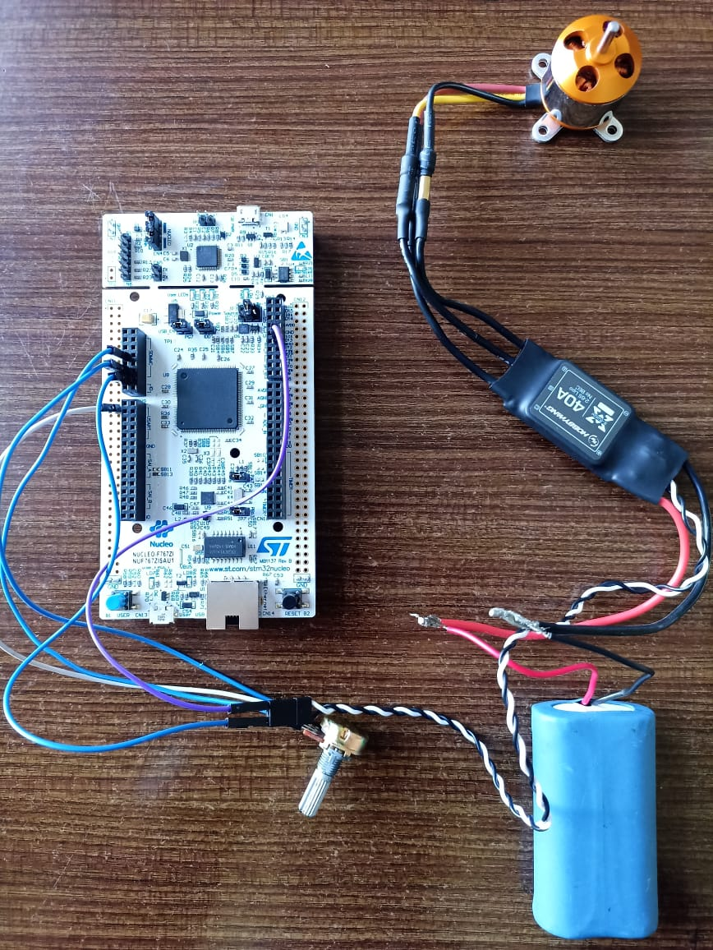

Chapter 7: Conclusion

- In this review phase, we successfully tested the STM32 board through basic LED control, ADC-based potentiometer input, and PWM generation for BLDC motor control.
- We verified that the microcontroller, GPIO, ADC, and PWM modules are functioning correctly.
- Although the BLDC motor did not rotate, the signals were generated as expected, which helped us identify where the interfacing issue lies.
- Overall, this stage gave us a strong foundation in understanding the complete signal flow and the control requirements needed for motor and battery management in a VCU system.

Chapter 8 : Future Work

- We plan to debug and complete the BLDC motor control by fixing driver interfacing and phase wiring issues.
- Our next step is to control a higher-rating motor to move closer to real vehicle-level performance.
- We will also start interfacing and monitoring the Battery Management System (BMS) parameters such as voltage, current, SOC, and temperature.
- Once motor and BMS control are stable, we will integrate both into the VCU workflow using CAN communication.

References:
- Evolving Electric Mobility Energy Efficiency: In-Depth Analysis of Integrated Electronic Control Unit Development in Electric Vehicles
- Automotive Software in Connected and Autonomous Electric Vehicles: A Review
- Requirements-Driven Automotive Electrical/Electronic Architecture: A Survey and Prospective Trends
- Electronic Control System Design and Test of Pure Electric Vehicle Battery Management System








Bengaluru City Office No 5/1, First Floor, Prestige Terraces, Union Street, Infantry Road, Bengaluru - 560003 Karnataka, India

GIMSR
GITAM Medical College Rd, Gandhi Nagar, Rushikonda, Visakhapatnam - 530045 Andhra Pradesh, India

